
ENDLESS EMPATHY


Student Name: Angelique Fernandez
Student Number: ST10504943
Module Name: Web Development (Introduction)
Module Code: WEDE5020

Table of Contents
1.ORGANISATION OVERVIEW: 2
2. WEBSITE GOALS & OBJECTIVES: 2
3.CURRENT WEBSITE ANALYSIS: 3
4.PROPOSED FEATURES & FUNCTIONALITY: 3
5.DESIGN & USER EXPERIENCE: 4
6. TECHNICAL REQUIREMENTS: 7
7. TIMELINE AND MILESTONES: 7
8.BUDGET 8
9.LOGO 9
10. REFERENCES 10

1.ORGANISATION OVERVIEW:
- Organisation Name: Endless Empathy
- Organisation Type: Non-Profit Organisation.
- Organisation History:
Endless Empathy is a community-focused non-profit organization, with the motto “Serving with Heart and Purpose.” The initiative is dedicated to providing support, care, and outreach to people in need in the community. Aiming to expand as time goes on. Created by Adrienne Brown in 2025, hoping to make the community better one act at a time.
- Mission Statement:
To serve communities with heart and purpose by providing meaningful, high-quality experiences and support that create positive change, bring people together, and make a lasting difference in the lives of those who need it most
- Vision:
To build stronger, more connected communities where everyone has the opportunity to experience dignity, joy, and meaningful support, regardless of their circumstances.
- Target Audience:
They provide support to children, families, elderly people and individuals from disadvantaged communities who may need assistance, resources or emotional and practical support. The organisation also targets people who would like to donate, volunteer or contribute towards helping others.

2. WEBSITE GOALS & OBJECTIVES:
- Goals:
The main goal for this project is to create a simple and easy to navigate website, which will provide valuable information about the business, explain the work they do, and make it easier for volunteers or doners to be involved, The website will also help increase the website traffic and increase awareness of the organisation and make it easier for people to donate, volunteer, enquire about assistance and support community projects.
- KPIs:
- Increase Enquiries through the website's contact form.
- Track how many people visit the Endless Empathy website every month and try to increase the website visitors.
- Increase the number of volunteers registering to help.
- Increase doners/ donations by making information easier to find.
- Increase awareness of the organisation and the communities and people it supports.
- Make information about receiving help and support easier for people to find.
- Provide a professional online presence for the organisation.

3.CURRENT WEBSITE ANALYSIS:
Not Applicable, since no website exists yet for Endless Empathy.

4.PROPOSED FEATURES & FUNCTIONALITY:
- Features:
Some of the essential features include:
- Homepage.
- About Us Page.
- Get Help Page.
- Volunteer Page.
- Donate Page.
- Contact Us Page.
- Functionality:
- Easy Navigation: Users can move easily between all the pages.
- Online Booking: Customers can make a booking request by entering their details, treatment/s, and date and time.
- Information: Users can view the information such as support offered.
- Get Help: People who require assistance can find information on how to contact Endless Empathy and request support.
- Donation Information: Users can find information about how they can donate and support the organisation.
- Volunteer Information: People can submit their details if they are interested in volunteering.
- Contact Information: Information about how to reach the organisation.
- Call-to-Action Buttons: Buttons such as “Donate Now,” “Volunteer,” and “Get Help” that will make it fast and easy for people to take charge.

5.DESIGN & USER EXPERIENCE:
The overall design will have a calm feel to it. Foreshadowing the relaxation and calm that is coming the client’s way. The calm and professional design will match the wellness services provided by Healing Hands.
- Colour Scheme:
The colours were chosen to represent kindness, empathy, hope, and trust. We chose:
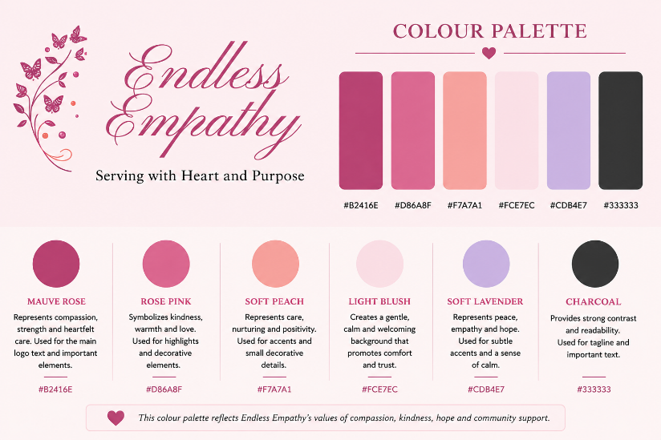
- Typography:
- FONTS
Wanting the font to look professional and elegant we chose:
Playfair Display- Will be used for the headings or subheadings.
Times New Roman- Will be used for the body of the text/website as well as the tagline.
Brittant Signature- Will be used only on the Logo.
- SIZE
Heading size will be large and will be used to clearly separate each section.
Body Text will be medium sized with more than enough spacing to make it easy to read.
- COLOUR
Black (#00000) will be the font colour of choice, for body text.

- Layout and Design:
Homepage:
The home page will have the logo present and information about the organisation.
Donate Page:
The page will provide information about how people can support Endless Empathy through donations.
Get Help Page: This page will provide information for people who may need assistance and explain how they can contact Endless Empathy.
Volunteer Page: The page will explain the different ways people can volunteer and include a simple form where users can submit their details.
About us page: Will explain more about the organisation and its vision.
Contact us page: Will give users a section to find the organisation details.
The overall design will have a warm, clean and welcoming appearance with soft colours, helping users feel that Endless Empathy is a safe and caring organisation.
- Wireframes:

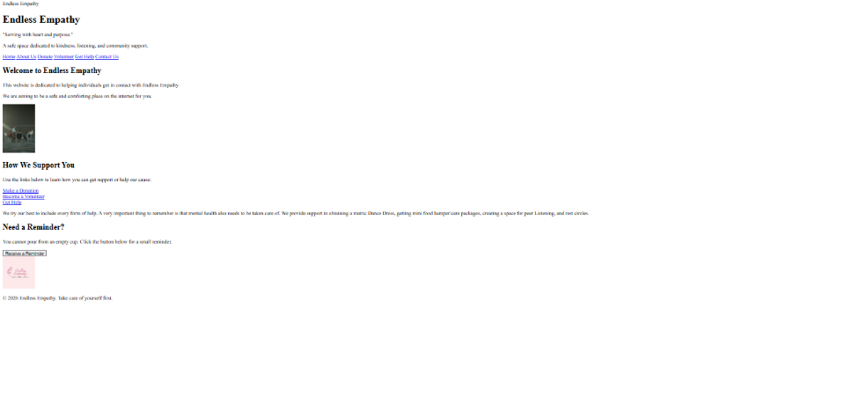

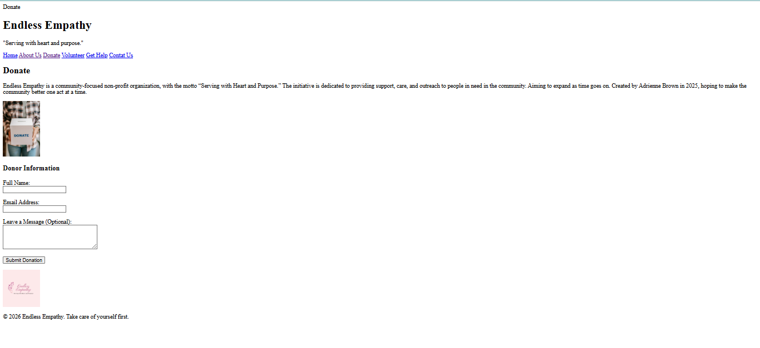

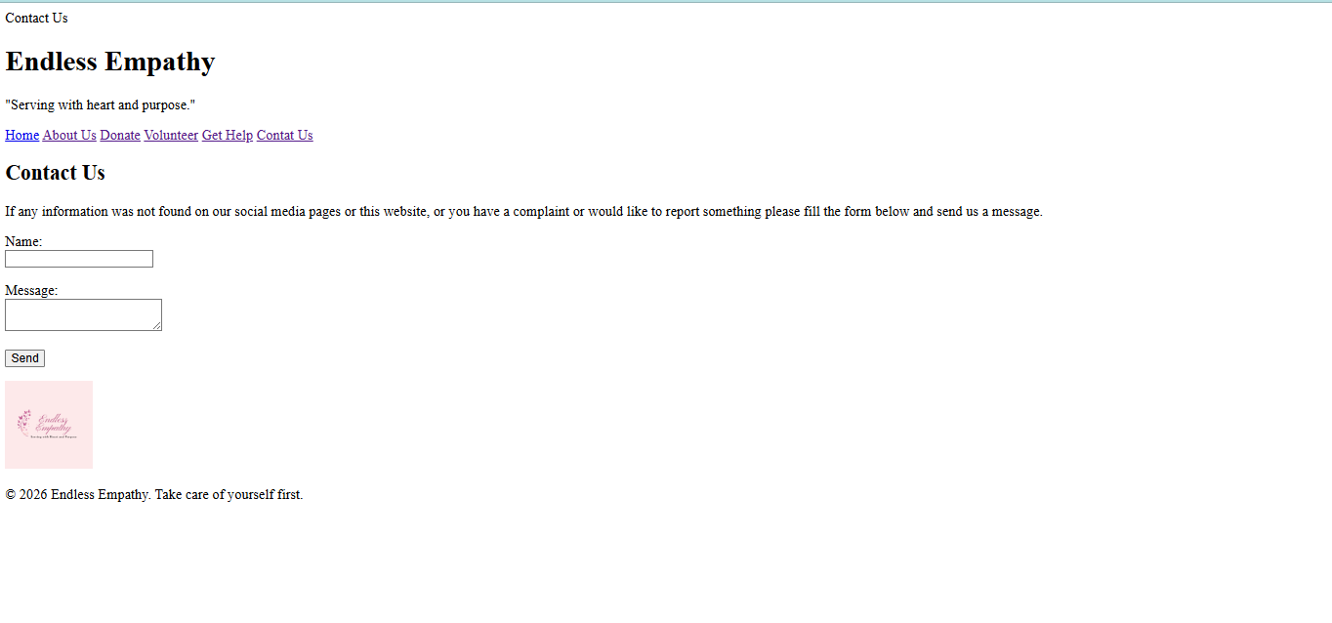
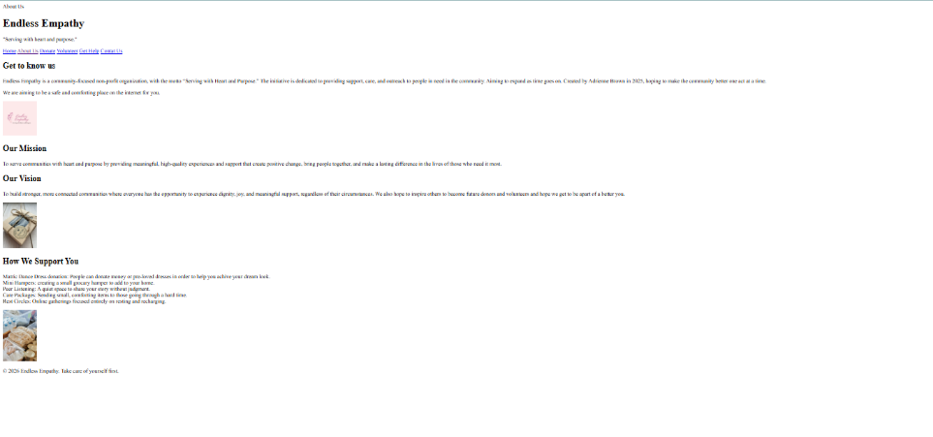
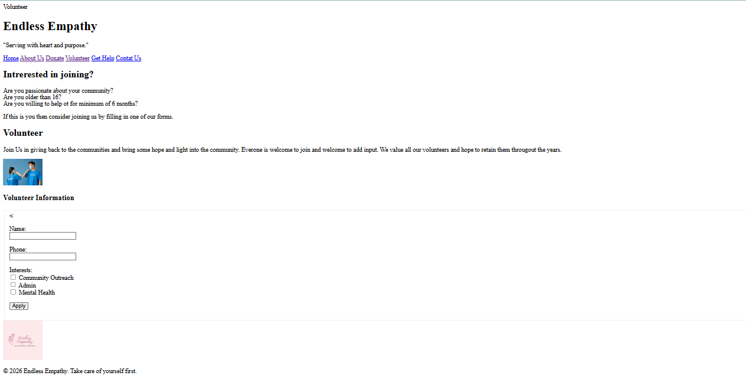
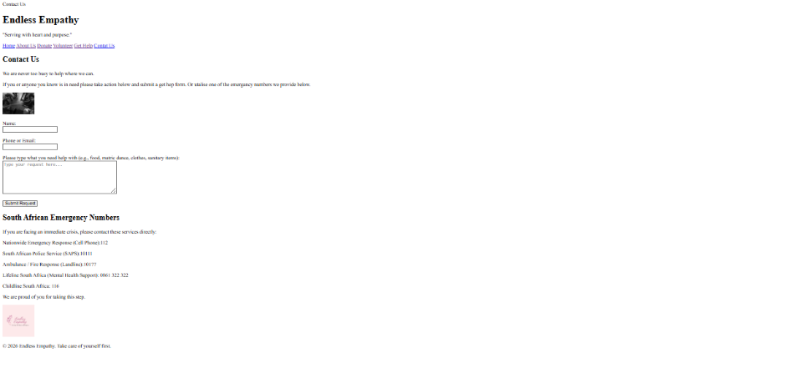

6. TECHNICAL REQUIREMENTS:
HTML, CSS and JavaScript will be used to create the website. HTML will be used to create the structure of the pages, CSS will be used for the layout and appearance, and JavaScript will be used for basic interactive features. The website will need to work correctly on different web browsers and screen sizes. Due to budget constraints, we will have our forms hosted on google.

7. TIMELINE AND MILESTONES:
STAGE | TIME ESTIMATED
Research & Planning | 7-10 August
Meeting 1 with organisation | 11 August
Create sitemap, website structure, and wireframes | 13 August
Website design | 13 August – 15 August
Create basic HTML Structure | 15 August – 17 August
Proposal (Start to submission day) | 10 August – 21 August
Organisation Update Message | 21 August
Website Development | 24 August – 11 SEPTEMBER
Testing & Corrections | 11 September – 14 September
Hosting and final reviews | 14 September- 15 September
Finalisation | 15 September- 17 September
Maintenance | 18 September Onwards

Based on the different stages of the development, the timeline may change, depending on the challenges and changes that may arise.

8.BUDGET
Because it is an NPO and I am a student, the website development will be free of charge.
For the domain and hosting costs, the NPO would like to spend a minimal amount on it as they are relatively new. Therefore, we will be hosting the website either on Cloudflare or Wix.
According to Venter, C(2026), an SSL Certificate is a Secure Sockets Layer. This is a standard technology to create an encrypted link between a web server and a browser.
ITEM | ESTIMATED COST | MOBILE APP
Website Development | R0 | Student
Hosting website | R0 | Free Platform like Cloudflare or GitHub Pages
Domain/ Subdomain | R0 | Free Platform like Cloudflare or GitHub Pages
SSL Certificate | R0 | Free Platform like Cloudflare or GitHub Pages (included)

The Endless Empathy website will not initially include online shopping or payment features. The donation section can initially provide information on how people can donate or contact the organisation about donating. If an online payment or donation system is added in the future, additional development, payment gateway and security costs may be required.

9.LOGO
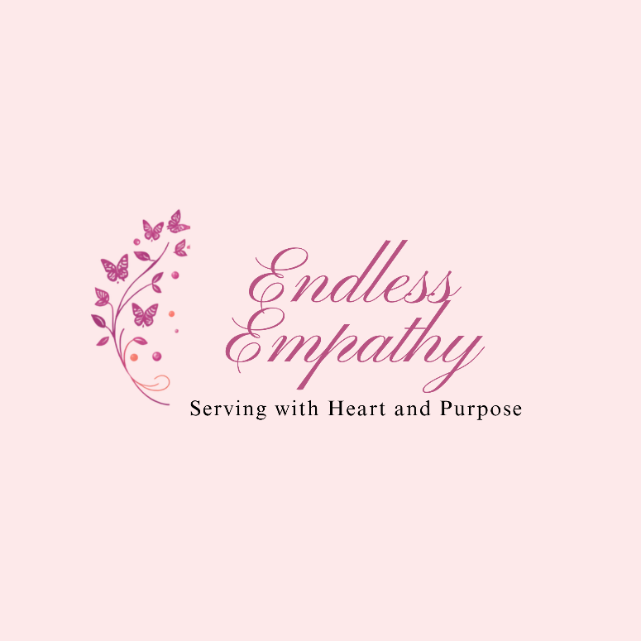

10. REFERENCES
Algosoft. 2026. Mobile app development cost in South Africa: 2026 guide. [Online.] Available at: https://www.algosoft.co/locations/mobile-app-development-cost-in-south-africa [Accessed 7 August 2026].
Canva,2026. Generated [image online] Available at: https://www.canva.com/design/DAHE_rAc9F0/t-woDZGSMeiZ4PcXQxLQIA/edit [Accessed 6 August 2026].
Cloudflare, 2026. Pricing [online]. Available at: https://www.cloudflare.com/plans/ [Accessed 18 August 2026].
Digital Platforms. n.d. Website development cost South Africa: Your guide. [Online.] Available at: https://www.digitalplatforms.co.za/website-development-cost-south-africa-your-guide/ [Accessed 7 August 2026].
Elementor. n.d. How much does a WooCommerce store cost? [Online.] Available at: https://elementor.com/blog/how-much-does-a-woocommerce-store-cost/ [Accessed 7 August 2026].
Google. 2026. Gemini (3.1 Pro) [Large language model] Available at: https://gemini.google.com/ [Accessed: 6 August 2026].
GSDM Agency. 2026. How much does it cost to hire a mobile app developer? [Online.] Available at: https://gsdm.co.za/blog/mobile-app-developer-cost-south-africa.html [Accessed 6 August 2026].
IIE,2026. Web Development (Introduction) (WEDE5020/d/p/w). Module Manual. [Word docx] IIE Available at: https://advtechonline.sharepoint.com/:w:/r/sites/TertiaryStudents/_layouts/15/Doc.aspx?sourcedoc=%7BF997A490-B112-4B5A-BC0C-93BE788D3EDA%7D&file=WEDE5020wPOE.docx&action=default&mobileredirect=true [Accessed 6 August 2026].
Mintbit. n.d. Top 7 low/no-code platforms for building an MVP. [Online.] Available at: https://www.mintbit.com/blog/top-7-low-slash-no-code-platforms-for-building-an-mvp/ [Accessed 7 August 2026].
New Perspective Studio. n.d. What is the cost of creating a website in South Africa? [Online.] Available at: https://www.newperspectivestudio.co.za/wp/what-is-the-cost-of-creating-a-website-in-south-africa/ [Accessed 7 August 2026].
OmniCore Agency. n.d. Best no-code website builders. [Online.] Available at: https://www.omnicoreagency.com/best-no-code-website-builders/ [Accessed 7 August 2026].
OpenAI. 2026. Chat-GPT (version 5.6 Luna) [Large language model]. Available at: https://chatgpt.com [Accessed 10 August 2026].
Origami Digital. 2026. How much does a website cost in South Africa? 2026 pricing guide. [Online.] Available at: https://origami-digital.co.za/journal/website-cost-south-africa [Accessed 6 August 2026].
Sharma, R. 2025. App development timeline – time it takes to design, develop & launch the app. Markovate. [online]. Available at: https://markovate.com/blog/app-development-timeline/ [Accessed 7 August 2026].
The Formula Lab. n.d. App development cost guide. [online]. Available at: https://www.theformula.co.za/app-development-cost-guide/ [Accessed 7 August 2026].
Venter, C., 2026. SSL certificate meaning unpacked: what is SSL certificate and which type is best for your website? Domains.co.za Blog [online]. 29 April. Available at: https://www.domains.co.za/blog/ssl-certificate-meaning/ [Accessed 18 August 2026].
Wix.com, 2026. Free web hosting built right into your site [online]. Available at: https://www.wix.com/lp-en/hosting [Accessed 18 August 2026].
Zealousys. 2026. How much does it cost to develop a mobile app in South Africa? [online]. Available at: https://zealousys.com/blog/mobile-app-development-costs-in-south-africa/ [Accessed 6 August 2026].

